Lung-AI-manuscript-xxm-0.6 2025-11-28
AI-Based Assessment of Tumor Regression and Peritumoral Immune Cells Density Predicts Outcomes in Non-pCR Lung Squamous Cell Carcinoma Following Neoadjuvant Immunochemotherapy

Abstract(结构化)
Background:
Neoadjuvant immunochemotherapy is increasingly employed for non-small cell lung cancer (NSCLC), but accurately evaluating treatment response and prognosis remains challenging, especially in patients without pathological complete response (non-pCR). Beyond residual viable tumor (RVT) assessment, additional biomarkers reflecting the tumor microenvironment are needed to improve postoperative risk stratification.
Methods:
We developed a multi-scale artificial intelligence (AI)-based pathology framework to quantify RVT, incorporating a foundation model-based cell detection and classification module to assess peritumoral immune cell density 最远检测 700-μm margin of the tumor boundary. Concordance between AI-derived RVT (AI-RVT) and visual RVT (VIS-RVT) was assessed using intraclass correlation coefficients (ICCs). Associations with disease-free survival (DFS) and overall survival (OS) were evaluated using Kaplan-Meier Log-rank and multivariable Cox analyses.
Results:
AI-RVT showed high concordance with VIS-RVT (ICC = 0.86-0.93), achieving 95.2% agreement in classifying MPR versus non-MPR at the 10% cutoff, and provided superior DFS stratification compared with VIS-RVT after adjustment for ypN status in the non-pCR cohort (p = 0.040). Meanwhile, both continuous AI-RVT and VIS-RVT were independently associated with shorter DFS (AI-RVT: HR = 7.0, p = 0.037; VIS-RVT: HR = 7.2, p = 0.018), but RVT alone did not adequately stratify OS risk.

In contrast, peritumoral lymphocyte enrichment independently predicted improved OS in patients with residual disease (HR = 0.034, p < 0.001), with this protective effect persisting in the non-MPR subgroup (HR = 0.10, p = 0.032).
Conclusions:
This study demonstrate that tumor burden and spatial immune features represent distinct yet synergistic dimensions of treatment response, supporting the incorporation of AI-enabled, spatially resolved digital pathology biomarkers into postoperative risk assessment and therapeutic decision-making following neoadjuvant immunochemotherapy.

Keywords:
LUSC, AI pathology, residual viable tumor, peritumoral immune cell, neoadjuvant immunochemotherapy, digital biomarkers, prognosis

Abstract(NM非结构化)
Neoadjuvant chemoimmunotherapy has improved pathological response rates in non-small-cell lung cancer, yet prognostic assessment remains challenging in patients who do not achieve pathological complete response (non-pCR). Conventional residual viable tumor (RVT) evaluation is labor-intensive and may insufficiently capture microenvironmental alterations induced by treatment. We developed a multi-scale artificial intelligence (AI) pathology framework using whole-slide images to quantify RVT, incorporating a foundation model-based cell detection and classification module to assess peritumoral immune cell density within 500 μm of the tumor margin in lung squamous cell carcinoma (LUSC). Concordance between AI-derived RVT (AI-RVT) and visual RVT (VIS-RVT) was assessed using intraclass correlation coefficients (ICCs), and prognostic significance was evaluated for disease-free survival (DFS) and overall survival (OS). AI-RVT showed strong agreement with VIS-RVT (ICC = 0.86-0.93) and provided superior DFS prediction in the non-pCR subgroup (p = 0.040). Elevated peritumoral neutrophil density emerged as an independent adverse prognostic factor, associated with shorter DFS (HR = 3.38, p = 0.013) and OS (HR = 3.22, p = 0.020). Among patients without major pathologic response, high neutrophil density similarly predicted inferior DFS (HR = 3.66, p = 0.045) and showed a consistent trend for OS (HR = 3.05, p = 0.095). These findings demonstrate that integrating AI-derived RVT quantification with spatial immune profiling improves risk stratification after neoadjuvant chemoimmunotherapy in LUSC. Peritumoral neutrophils represent a robust biomarker beyond conventional pathological metrics and support the incorporation of spatially resolved digital pathology features into postoperative management and decision-making.
Keywords:
LUSC; AI pathology; residual viable tumor; peritumoral immune cells; neoadjuvant chemoimmunotherapy; prognosis

Introduction (NM)
Neoadjuvant immunochemotherapy has become a standard treatment option for resectable non-small-cell lung cancer (NSCLC), yielding substantially higher pathological response rates than chemotherapy alone in several clinical trials (e.g., CheckMate-816 and KEYNOTE-671)¹⁻⁴. Despite these advances, response evaluation and risk stratification remain challenging, especially for patients who do not achieve pathological complete response (non-pCR). The long-term CheckMate 816 results showed that non-pCR patients, who represent approximately 75% of those treated, had a 5-year overall survival of only 55.7%, compared with 95.3% in pCR patients, underscoring the high-risk nature of this major group. Current pathological assessment frameworks, such as residual viable tumor (RVT), provide important prognostic information but are labor-intensive and subject to interobserver variability⁵⁻⁸.
The limitations of currently used binary RVT-based thresholds, such as RVT >0% for non-pCR and RVT >10% for non-major pathologic response (non-MPR), are increasingly recognized. These criteria compress a continuous biological spectrum into coarse categories, weakening prognostic discrimination and potentially obscuring clinically meaningful variation in treatment response. Emerging evidence further indicates that modeling RVT as a continuous variable provides greater sensitivity for capturing survival risk, highlighting the imperative for more precise and reproducible RVT quantification.
Moreover, RVT-based metrics that focus solely on tumor regression do not fully capture the complex immune-tumor interactions induced by neoadjuvant immunochemotherapy. The tumor microenvironment (TME) features provide additional prognostic information. The abundance or patterns of immune infiltration, including neutrophils, lymphocytes, and stromal responses, have been linked to treatment sensitivity and survival in lung cancer⁹⁻¹². Prior studies have shown that lymphocyte-rich “hot” tumors are associated with improved immunotherapy response⁹, whereas tumor-associated neutrophils contribute to immune evasion and poor prognosis¹⁰⁻¹². However, these microenvironmental features are not routinely quantified in pathological practice due to their labor-intensive nature and limited reproducibility, and their prognostic relevance in the neoadjuvant immunochemotherapy setting, particularly in lung squamous cell carcinoma (LUSC), remains insufficiently defined.
Recent advances in artificial intelligence (AI)-based digital pathology have enabled reproducible, high-throughput quantification of RVT and TME features from whole-slide images (WSIs). AI-derived RVT has demonstrated strong concordance with pathologist assessment and prognostic value in patients receiving neoadjuvant immunotherapy alone¹³. Yet, it is unknown whether AI-derived metrics retain predictive utility in the context of neoadjuvant immunochemotherapy, now the predominant neoadjuvant strategy, and how these quantitative features interact with key clinical variables such as nodal status. Meanwhile, increasing evidence indicates that the spatial composition and organization of tumor and stromal immune cells within the TME can be quantitatively characterized using deep learning–based pathology models and serve as independent prognostic factors in lung adenocarcinoma^{14,15}. Notably, an AI-based whole-slide analyzer capable of identifying cancer areas, stroma and key TME components, including tumor-infiltrating lymphocytes, fibroblasts and endothelial cells, was shown to delineate dynamic microenvironmental changes in EGFR-mutant NSCLC following TKI resistance and to predict subsequent response to immunotherapy-based treatment¹⁶. These findings underscore the broader relevance of AI-derived spatial TME features for informing immunotherapy response and motivate their integration into RVT-based survival modeling, particularly for the non-pCR population.
Therefore, leveraging datasets from two cohorts at the National Cancer Center (NCC_Cohort1 and NCC_Cohort2) together with additional external cohorts from Shanxi Cancer Hospital (SXCH) and Shenzhen Cancer Hospital (SZCH), we developed a multi-scale AI-powered pathology framework that simultaneously quantifies RVT, and incorporated a foundation model-based cell detection and classification module to obtain peritumoral immune cell density from WSIs of LUSC treated with neoadjuvant immunochemotherapy. This integrative approach aims to enhance postoperative risk stratification, particularly among non-pCR patients, and to provide a more biologically grounded basis for informing adjuvant treatment decisions and clinical surveillance.

Results
- The AI framework enables accurate quantification of residual tumor and peritumoral immune cells
(2025-7-28 modified)
The advantages of the multi-scale architecture design were fully validated by experimental results in Figure 2a. Across six independent experiments, our method demonstrated significant performance improvements over single-scale models in classifying four representative pathological regions (e.g., tumor bed, and tumor). Quantitatively, the multi-scale model achieved average relative improvements of 47.2%, 48.2%, and 53.3% in F1-score, precision, and recall²⁷, respectively (Figure 2a). This substantial performance enhancement confirms that multi-scale feature fusion effectively overcomes the limitation of disconnection between local features and global context under single-resolution analysis, particularly demonstrating superior discriminative capability for therapy-induced complex tissue alterations (e.g., fibrotic areas admixed with residual tumor).
The performance of the multiclass cell detection model was evaluated across seven peritumoral immune cell categories (Fig. 2c). We adopted the large pretrained vision-language model, GLIP(Li L H, Zhang P, Zhang H, et al. Grounded language-image pre-training[C]//Proceedings of the IEEE/CVF conference on computer vision and pattern recognition. 2022: 10965-10975.), as the detection backbone because it obviates the need for task-specific classification heads and enables the joint pretraining on large-scale public datasets with inconsistent label spaces. To validate this approach, we benchmarked our framework against the conventional Mask R-CNN and a baseline GLIP model trained without public datasets. The proposed framework consistently outperformed both baselines, achieving higher AP50(Lin T Y, Maire M, Belongie S, et al. Microsoft coco: Common objects in context[C]//European conference on computer vision. Cham: Springer International Publishing, 2014: 740-755.) across all evaluated classes, with Mask R-CNN²⁴ even failing to identify eosinophils as a distinct class. Compared with Mask R-CNN, these improvements indicate that foundation-model-based representations provide more expressive and transferable features than conventional detection architectures, reducing overfitting and improving generalization across morphologically diverse immune cell populations. Moreover, superiority over GLIP without additional pretraining underscores the importance of progressive domain-adaptive pretraining. Incorporation of large-scale public histopathology datasets followed by in-domain pretraining enabled the model to establish cell-aware visual features aligned with the histological domain and in-domain staining characteristics, resulting in enhanced detection performance.
Collectively, these results demonstrate the reliability of the AI framework for quantitative pathological assessment.

Figure 2. Performance of the multi-scale patch classification and multi-class cell detection model
(A) Bar plot comparing F1-score, precision, and recall of the multi-scale (with MS) and single-scale (without MS) models across four pathological regions. Within each box plot, the center line represents the mean and the error bar indicates the standard deviation across six independent runs. (B) Representative whole-slide image showing multi-scale patch classification results. “Pred” indicates prediction results, “GT” indicates ground truth. (C) Bar plot comparing AP50 of the multi-class cell detection model, Mask R-CNN, and GLIP without additional pretraining across seven peritumoral immune cell categories. (D) Illustration of the multi-class cell detector applied to peritumoral tiles, demonstrating representative detection results.
- AI-RVT demonstrates strong agreement with VIS-RVT across independent validation and test cohorts (2025-12-11 modified)
The multi-scale AI model was trained on 251 annotated slides from 20 cases in NCC_cohort1 and was evaluated in an independent external validation SXCH cohort, as well as a multi-institutional test cohort comprising NCC_cohort2 and SZCH (Fig. 3).
Across the validation cohort, AI-RVT showed strong concordance with VIS-RVT at both the slide level (ICC = 0.881, p = 1.08 × 10⁻⁶⁴; Fig. 3A) and the patient level (ICC = 0.861, p = 6.03 × 10⁻¹⁰; Fig. 3B). Representative comparisons between pathologist annotations (Fig. 3C) and AI-generated segmentation maps (Fig. 3D) further illustrate the high fidelity of AI-based detection. Similar results were observed in the test datasets, with ICCs of 0.861 (p = 6.96 × 10⁻²⁷³) at the slide level (Fig. 3E) and 0.931 (p = 1.05 × 10⁻³⁸) at the patient level (Fig. 3F).
Using the established 10% cutoff for MPR classification, AI-RVT achieved a concordance rate of 95.2% (80/84) with VIS-RVT (Fig. 3G). Three of the four discordant cases (t1, t3, t4) exhibited values near the cutoff, reflecting borderline differences rather than systematic error. Only Case_t2 showed a notable discrepancy (VIS-RVT 22% vs. AI-RVT 8.56%), attributable to extensive interwoven stromal regions that visually complicated RVT estimation (Fig. 3H). Such heterogeneity may bias manual quantification toward overestimating viable tumor.
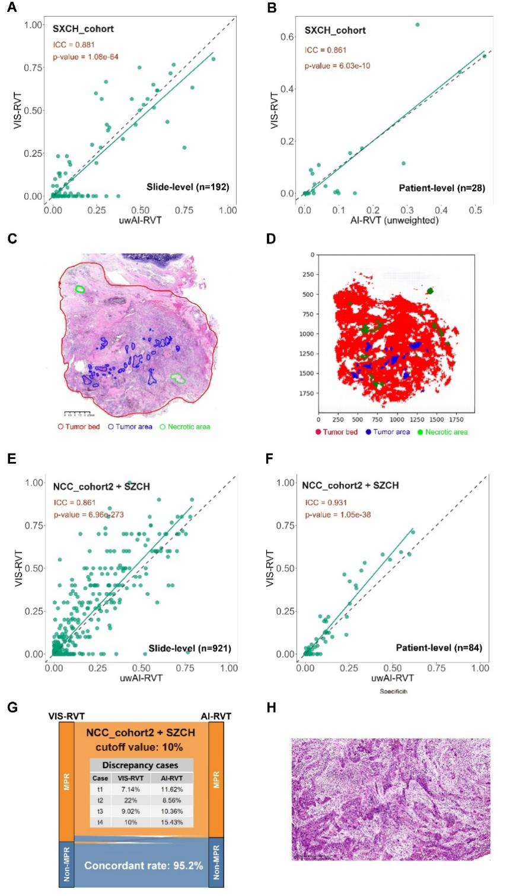
Figure 3. Assessment of model performance using ICC and concordance analyses across validation and independent test datasets.
ICC analysis between VIS-RVT and AI-RVT in validation dataset (SXCH) at the slide-level (A) and patient-level (B). Representative image with pathologist annotations (C) and the corresponding AI-generated tissue segmentation map (D), illustrating tumor bed (red), tumor area (blue), and necrotic area (green). AI-model performance in the independent test dataset (NCC_cohort2 + SZCH), showing ICC between VIS-RVT and AI-RVT at the slide level (E) and patient level (F). (G) Sankey diagram summarizing case-level concordance between VIS-RVT and AI-RVT classifications using a 10% cutoff. Examples of discrepant cases (t1–t4) are listed, and the overall concordance rate is shown. (I) High-power H&E image of Case_t2, illustrating extensive interwoven stromal regions, which contributed to the observed discrepancy between VIS-RVT and AI-RVT.

- Prognostic relevance of AI-RVT and VIS-RVT in the overall and non-pCR cohorts
To evaluate prognostic relevance, progression-free survival (PFS) and overall survival (OS) analyses were conducted in a combined cohort of 103 patients (NCC_cohort1, NCC_cohort2 and SZCH). Both VIS-RVT- and AI-RVT-defined MPR significantly stratified DFS (VIS-RVT: p = 0.0011, Fig. 4A; AI-RVT: p = 0.00095, Fig. 4B). While OS stratification was limited. VIS-RVT did not significantly predict OS (p = 0.33, Fig. 4C), whereas AI-RVT showed a nonsignificant trend (p = 0.084, Fig. 4D).
In multivariable Cox analyses adjusting for ypN status, both VIS-RVT-defined and AI-RVT-defined MPR remained independently associated with improved DFS (VIS-RVT: HR = 2.6, 95% CI 1.09-6.20, p = 0.031; AI-RVT: HR = 2.7, 95% CI 1.18-6.40, p = 0.019; Fig. 4E-F). ypN status did not reach significance in either model. Neither VIS-RVT nor AI-RVT predicted OS in multivariable models (p > 0.05; Fig. 4G-H).
Given that pCR is an established indicator of long-term favorable prognosis in LUSC treated with neoadjuvant immunochemotherapy², we subsequently focused our analyses on the non-pCR subgroup, which accounted for approximately 75.7% (78/103) of the combined cohort in our study. Both VIS-RVT and AI-RVT continued to significantly stratify DFS (VIS-RVT: p = 0.023, Fig. 4I; AI-RVT: p = 0.021, Fig. 4J), but not OS (p = 0.84 and p = 0.34; Fig. 4K-L). In adjusted Cox models, AI-RVT-defined non-MPR status remained an independent predictor of shorter DFS (HR = 2.5, 95% CI 1.04-6.0, p = 0.040; Fig. 4N), whereas VIS-RVT showed a borderline association (HR = 2.3, p = 0.061; Fig. 4M). No significant OS associations were observed for either method (Fig. 4O-P).
To reduce information loss from dichotomizing RVT (MPR vs. non-MPR) at the 10% threshold, continuous RVT values were further analyzed. In the overall cohort, both continuous VIS-RVT and AI-RVT were independently associated with shorter DFS (VIS-RVT: HR = 8.4, p = 0.009; AI-RVT: HR = 8.2, p = 0.022; Supplementary Fig. 1A-B), whereas neither metric showed a significant association with OS (all p > 0.05; Supplementary Fig. 1C-D). Similar patterns were observed in the non-pCR subgroup, where continuous VIS-RVT and AI-RVT remained significant predictors of DFS (VIS-RVT: HR = 7.2, p = 0.018; AI-RVT: HR = 7.0, p = 0.037; Supplementary Fig. 1E-F), but not of OS (all p > 0.05; Supplementary Fig. 1G-H). Collectively, these findings indicate that continuous RVT provides a more sensitive and quantitative marker of DFS risk than dichotomous cutoff-based definitions, particularly among patients with non-pCR.

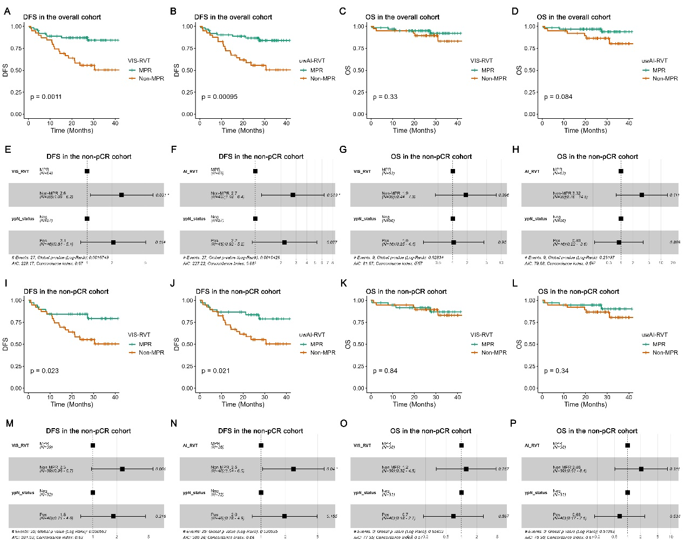
Figure 4. Prognostic value of AI-based and visual RVT assessment in the overall and non-pCR populations.
(A) Kaplan–Meier survival curves comparing DFS and OS between MPR and non-MPR groups defined by visual (VIS-RVT) and AI-based (AI-RVT) RVT assessment in the overall patient cohort (n = 103). (E-H) Corresponding multivariate Cox proportional hazards models adjusting for nodal status (ypN0 vs. ypN1-2) confirmed the independent prognostic value of AI-RVT and VIS-RVT for DFS. While, neither method showed a significant association with OS. (I-L) Kaplan–Meier survival curves restricted to the non-pCR subgroup (n = 78), showing that both VIS-RVT and AI-RVT continued to significantly stratify patients by DFS, but not by OS. (M-P) Multivariate Cox models in the non-pCR subgroup showed that AI-RVT-based non-MPR status was significantly associated with worse DFS (HR = 2.5, p = 0.040), while VIS-RVT showed a borderline effect. No significant hazard ratios were observed for OS prediction in this subgroup using either method.

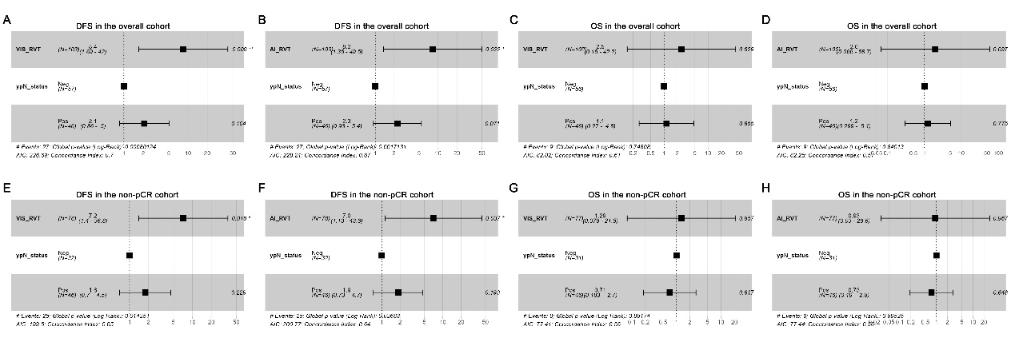
Supplementary Figure 1. Multivariable analyses for DFS and OS in the whole and non-pCR cohorts.
Multivariable Cox regression analyses evaluating the prognostic significance of AI-RVT and VIS-RVT for DFS and OS in both the overall cohort and the non-pCR subgroup. All models were adjusted for nodal status (ypN). Panels A-D show results for the entire cohort, while panels E-H present the corresponding analyses within the non-pCR population. The asterisks denote statistical significance (*p < 0.05).

4. Spatially resolved immune architecture reveals distance-dependent prognostic effects
To investigate whether the prognostic relevance of the tumor microenvironment exhibits spatial dependency, we first developed a H&E-based artificial intelligence model enabling morphology-driven classification of major immune cell populations. Using this framework, we systematically quantified immune cell distributions surrounding the dominant tumor focus within a predefined sampling region extending to a maximal measurable distance of approximately 700 μm.
Cell densities were computed within concentric radial intervals ranging from 50 to 700 μm at 50-μm increments. Based on these spatially resolved density profiles, Cox proportional hazards analyses were performed across increasing distances from the tumor focus. Strikingly, the associations between cellular components and survival outcomes exhibited marked spatial heterogeneity (Fig. 5A).
Neutrophils and lymphocytes demonstrated comparatively robust prognostic effects that were spatially stable across extended distances, whereas other immune and stromal populations displayed associations restricted to narrower spatial intervals. These findings motivated focused analyses of neutrophil and lymphocyte distributions.
Neutrophils displayed a predominantly adverse prognostic association within the tumor-proximal niche. Elevated neutrophil density within 50 μm was significantly associated with inferior disease-free survival (DFS) (log-rank P = 0.007) (Fig. 5B) and overall survival (OS) (log-rank P = 0.01) (Fig. 5C), whereas neutrophil densities at larger distances did not show consistent survival associations. Conversely, lymphocytes exhibited a spatially distinct pattern. While lymphocyte density within 50 μm was not associated with DFS or OS, increased lymphocyte density within 700 μm was associated with improved DFS (log-rank P = 0.019) (Fig. 5B) and OS (log-rank P = 0.029) (Fig. 5D).
This spatial divergence supports the presence of a stratified immune architecture, whereby neutrophils preferentially contribute to prognostic effects within the immediate peritumoral niche, whereas lymphocyte-associated effects become more apparent at extended spatial scales.
To determine whether spatially selected cellular features retained independent prognostic significance, we constructed multivariable Cox models incorporating clinicopathological covariates. For DFS, neutrophil density within 50 μm remained independently associated with recurrence risk (HR = 3.57, P = 0.007), whereas lymphocyte density within 700 μm did not retain independent significance (Fig. 5E).
For OS, firth-corrected Cox regression was applied. In this model, lymphocyte density within 700 μm emerged as an independent protective factor (HR = 0.13, P = 0.022), while neutrophil density within 50 μm remained independently associated with adverse survival (HR = 6.2, P = 0.022) (Fig. 5F).
Together, these analyses demonstrate that the prognostic impact of the tumor microenvironment is strongly distance-dependent, with innate immune components dominating the immediate peritumoral niche and adaptive immune effects emerging at larger spatial scales.

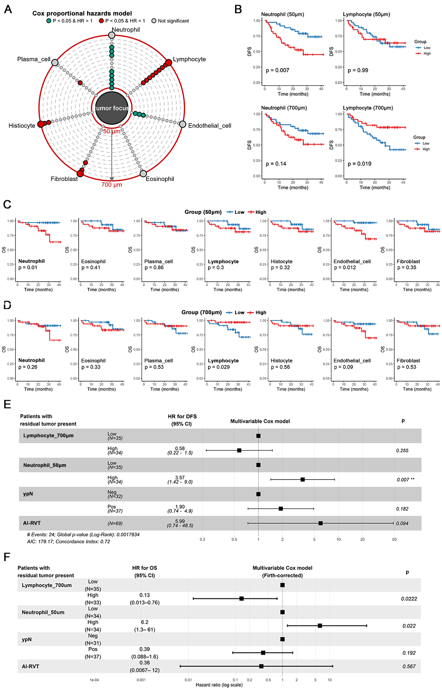
Figure 5. Spatially resolved immune microenvironment features associated with survival outcomes.
(A) Radial summary of Cox proportional hazards analyses showing HRs for DFS across spatial distances from the tumor focus. Each dot represents the HR for cell densities measured within the indicated distance.
(B) KM curves for DFS stratified by high versus low cell densities measured within representative distances (50 μm and 700 μm). Neutrophil density within 50 μm was associated with inferior DFS, whereas lymphocyte density within 700 μm was associated with improved DFS.
(C-D) KM curves for OS according to immune and stromal cell densities measured within 50 μm (C) and 700 μm (D).
(E) Multivariable Cox proportional hazards model for DFS incorporating spatial cellular features (lymphocytes within 700 μm, neutrophils within 50 μm) and clinicopathological covariates (ypN stage and AI-derived residual tumor viability [AI-RVT]). Forest plots show HRs with 95% confidence intervals (CIs).
(F) Multivariable Firth-corrected Cox regression model for OS using the same covariates.
HR, hazard ratio; CI, confidence interval; DFS, disease-free survival; OS, overall survival; ypN, post-treatment nodal stage; AI-RVT, AI-derived residual tumor viability.

5. Spatially coordinated lymphocyte-neutrophil immune phenotypes stratify survival outcomes
Given the spatially distinct prognostic patterns of lymphocytes and neutrophils, we next evaluated whether their coordinated spatial distributions provided additional prognostic resolution. Patients were categorized into coordinated lymphocyte-neutrophil (Lym+Neu) immune phenotypes based on lymphocyte density within 700 μm and neutrophil density within 50 μm (Fig. 6A).
In patients with residual tumor, Lym+Neu phenotypes demonstrated significant discrimination of DFS. The neutrophil-enriched, lymphocyte-depleted phenotype was associated with inferior DFS compared with other phenotypes (log-rank P = 0.0036), with the most favorable outcomes observed in the neutrophil-depleted, lymphocyte-enriched phenotype (Fig. 6B). Multivariable Cox proportional hazards analysis confirmed that the neutrophil-enriched, lymphocyte-depleted phenotype retained independent prognostic relevance for DFS compared with the neutrophil-depleted, lymphocyte-enriched phenotype, after adjustment for ypN stage and AI-derived residual tumor viability (AI-RVT) (Fig. 6C).
Consistent survival stratification was observed for OS within the residual tumor subgroup. Patients exhibiting the neutrophil-enriched phenotype experienced significantly worse OS (log-rank P = 0.0063) (Fig. 6D). Firth-corrected Cox regression further demonstrated that the lymphocyte-depleted, neutrophil-enriched phenotype independently predicted OS (P = 0.00146) (Fig. 6E).
We next evaluated the prognostic significance of Lym+Neu phenotypes in patients with non-MPR status. A similar outcome separation was observed for DFS, with the lymphocyte-depleted, neutrophil-enriched phenotype associated with inferior DFS (log-rank P = 0.011) (Fig. 6F). Multivariable analysis confirmed the independent prognostic significance of Lym+Neu phenotypes for DFS (P = 0.0093) (Fig. 6G).
By contrast, no significant OS differences were observed across Lym+Neu phenotypes in the non-MPR subgroup (Fig. 6H,I).
Together, these findings indicate that coordinated spatial lymphocyte-neutrophil immune phenotypes provide reproducible prognostic stratification and that peritumoral immune cell composition conveys prognostic information complementary to conventional pathological parameters, particularly in patients with residual disease.

、、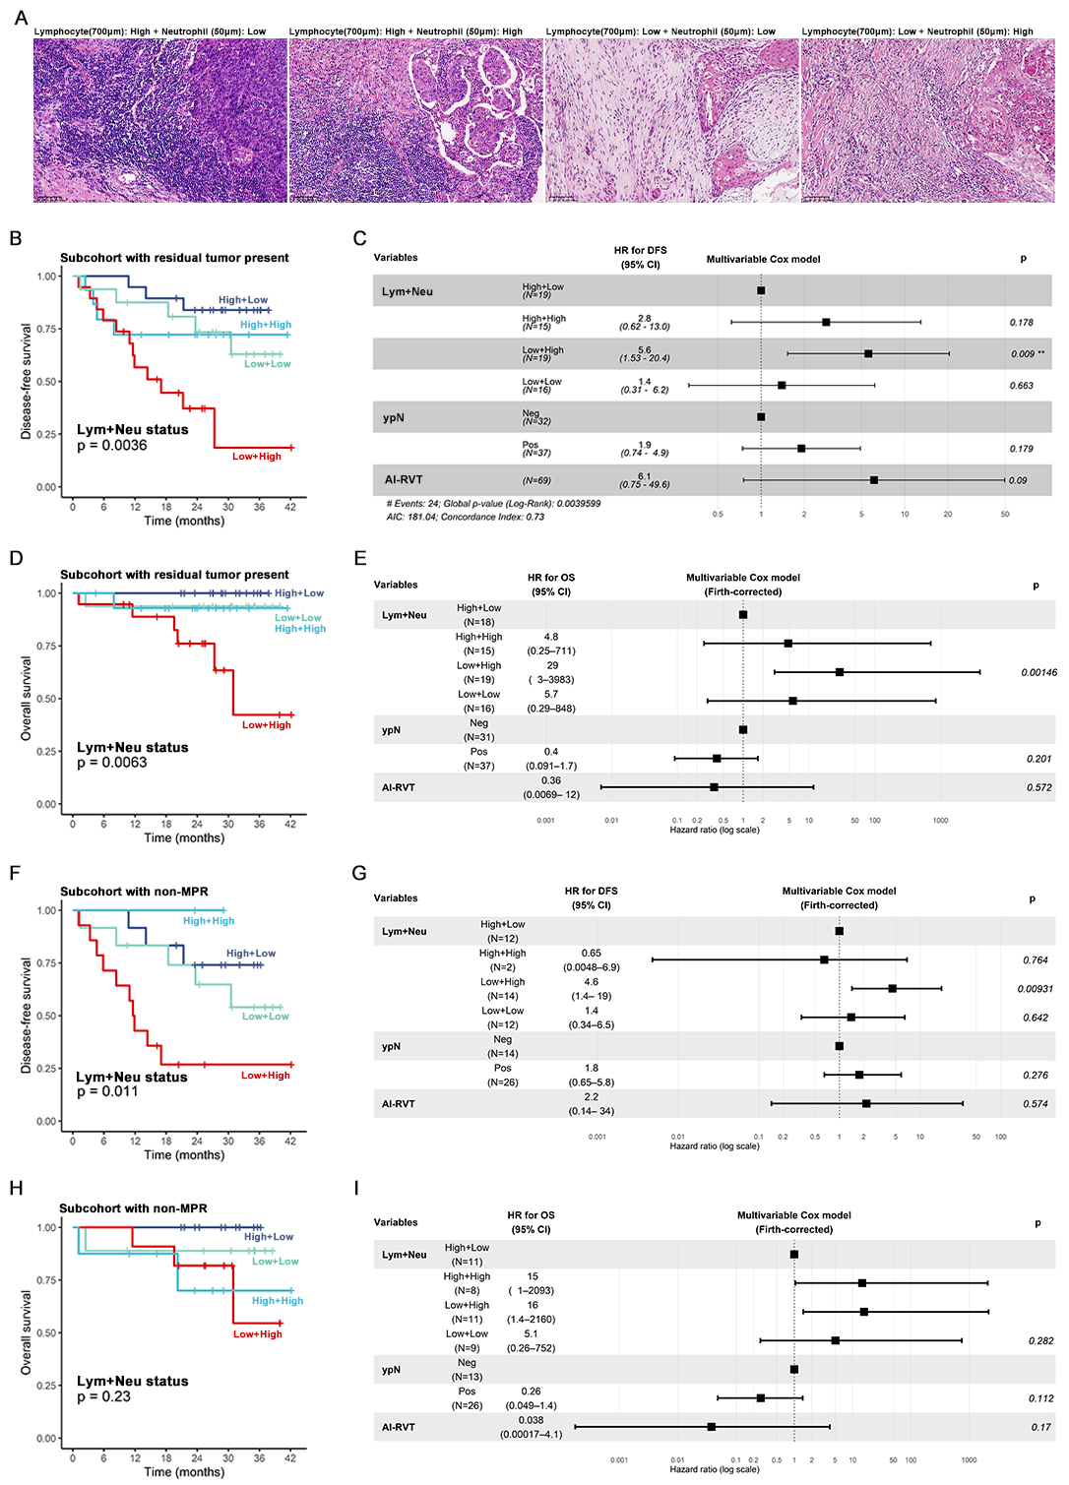
Figure 6. Spatially coordinated lymphocyte-neutrophil immune phenotypes and survival outcomes
(A) Representative H&E images illustrating spatial immune phenotypes defined by lymphocyte density within 700 μm and neutrophil density within 50 μm.
(B) KM curves for DFS stratified by joint lymphocyte-neutrophil (Lym+Neu) phenotypes in patients with residual tumor.
(C) Multivariable Cox proportional hazards model for DFS in patients with residual tumor, incorporating Lym+Neu phenotypes, ypN stage, and AI-derived residual tumor viability (AI-RVT). Forest plots show HRs with 95% CIs.
(D) KM curves for OS according to Lym+Neu phenotypes in patients with residual tumor.
(E) Multivariable Firth-corrected Cox regression model for OS in patients with residual tumor.
(F) KM curves for DFS stratified by Lym+Neu phenotypes in patients with non-MPR.
(G) Multivariable Cox proportional hazards model for DFS in non-MPR patients.
(H) KM curves for OS according to Lym+Neu phenotypes in non-MPR patients.
(I) Multivariable Firth-corrected Cox regression model for OS in non-MPR patients.

Discussion
This study introduces an AI-enabled pathology framework that integrates quantitative RVT assessment with spatially resolved peritumoral immune profiling to refine risk stratification following neoadjuvant immunochemotherapy in LUSC. By coupling tumor burden with spatial immune metrics, the framework enhances analytical reproducibility and provides improved prognostic discrimination compared with conventional visual RVT assessment. These results support the translational potential of AI-derived tumor-immune profiling for informing postoperative management in patients treated with neoadjuvant immunochemotherapy.
A major strength of this work is the development of a multi-scale deep learning architecture that emulates the pathologist’s interpretive process by combining high-resolution cellular features with low- resolution tissue context. This strategy enabled accurate identification of therapy-altered regions, including fibrotic tumor beds with admixed residual tumor, an area where single-resolution approaches frequently underperform. Across independent cohorts, AI-RVT showed strong concordance with expert pathologists (ICC 0.86-0.93) and high accuracy in MPR classification (95.2% concordance), establishing its technical reliability across multi-institutional datasets.
Importantly, the prognostic utility of AI-RVT extended beyond agreement with pathologists. Although both AI-RVT and VIS-RVT stratified DFS in the overall cohort, AI-RVT retained independent significance in the clinically critical non-pCR population after adjustment for ypN status, whereas VIS-RVT did not. Furthermore, modeling RVT as a continuous variable substantially strengthened prognostic associations across cohorts, highlighting the limitations of dichotomizing a biologically continuous measure at the conventional 10% MPR cutoff. These findings align with emerging evidence that RVT reflects a quantitative spectrum of treatment response and that information loss from binary thresholds can obscure clinically meaningful gradations. Together, these observations indicate that continuous RVT is a more sensitive and biologically grounded predictor of DFS, and that AI-derived RVT provides a reliable and reproducible approach to implement this concept in real-world clinical workflows.
Although RVT effectively predicted DFS, it did not significantly stratify OS, suggesting that tumor burden alone does not fully capture long-term survival-relevant biology. Incorporating peritumoral immune features, derived from multi-class cell detection using a GLIP-based network trained with a progressive pretraining - fine-tuning strategy, revealed complementary prognostic signals. A key conceptual advance of this study is the demonstration that immune prognostic effects exhibit spatial dependency. Consistent with established principles of TME biology⁹⁻¹², including the favorable impact of lymphocyte-rich “hot” tumors and the adverse effects of tumor-associated neutrophils, Neutrophils and lymphocytes exhibited distinct distance-dependent prognostic patterns, with neutrophil-associated adverse effects concentrated within tumor-proximal niches and lymphocyte-associated protective effects emerging predominantly at extended spatial scales. These findings support a model of spatial immune stratification, suggesting that immune contexture operates through compartmentalized biological mechanisms.
Integrating lymphocyte and neutrophil distributions further delineated coordinated spatial immune phenotypes with distinct prognostic implications. Notably, the phenotype characterized by lymphocyte depletion at extended spatial scales coupled with neutrophil enrichment within tumor-proximal regions exhibited the most adverse clinical trajectory. This immune configuration was consistently associated with inferior DFS and OS in patients with residual tumor and similarly conferred the poorest DFS in non-MPR populations. Neutrophil enrichment in close proximity to the tumor likely represents a high-risk inflammatory-invasive niche. Consistent with prior spatial analyses in lung adenocarcinoma, neutrophil enrichment within tumor-proximal niches has been associated with adverse outcomes relative to more distant peritumoral regions^{17,18}. These results support that neutrophil-mediated tumor-promoting mechanisms operate predominantly through short-range interactions, such as NET-associated effects¹⁸. In contrast, lymphocyte density became prognostically informative predominantly at extended spatial scales. Expanding the spatial scale enables resolution of higher-order immune organization, including tertiary lymphoid structures¹⁹, thereby capturing immune contexture that more faithfully reflects host immune competence and sustained antitumor surveillance^{9,20}.
Importantly, the differential prognostic contributions of RVT and peritumoral immune features appear to reflect a staged biological framework. AI-derived RVT functions as an initial response classifier, enabling robust identification of patients with pCR status who exhibit exceptionally favorable outcomes²¹. In patients with residual tumor, RVT further provides precise localization of the tumor locus, establishing an essential spatial reference for subsequent peritumoral immune profiling. This relationship highlights RVT as both a quantitative measure of treatment response magnitude and a critical spatial anchor for immune microenvironment interrogation.
This study has several limitations. First, its retrospective design may introduce selection bias, and prospective, multi-center validation will be essential to establish generalizability. Second, peritumoral immune features were derived from the largest tumor focus per slide; although this captures the dominant peritumoral milieu, regional heterogeneity across multiple tumor foci may not be fully represented. Third, although analyses were conducted on H&E WSIs to enhance clinical feasibility, future refinement through detailed immune cell subclassification, including separation of T and B lymphocytes, may further improve biological interpretability and model performance.
In summary, this study establishes an AI-driven, multi-scale pathology framework that integrates quantitative RVT measurement with peritumoral immune profiling to improve risk stratification after neoadjuvant chemoimmunotherapy in LUSC. Peritumoral lymphocyte density emerged as a robust and independent predictor of OS in patients with residual disease, providing prognostic information beyond conventional pathological indices. These findings support the incorporation of spatially resolved digital pathology biomarkers into postoperative decision-making and provide a foundation for prospective clinical validation and future therapeutic translation.

Reference
1. Forde, P.M., et al. Neoadjuvant Nivolumab plus Chemotherapy in Resectable Lung Cancer. The New England journal of medicine 386, 1973-1985 (2022).
2. Forde, P.M., et al. Overall Survival with Neoadjuvant Nivolumab plus Chemotherapy in Lung Cancer. The New England journal of medicine (2025).
3. Spicer, J.D., et al. Neoadjuvant pembrolizumab plus chemotherapy followed by adjuvant pembrolizumab compared with neoadjuvant chemotherapy alone in patients with early-stage non-small-cell lung cancer (KEYNOTE-671): a randomised, double-blind, placebo-controlled, phase 3 trial. Lancet 404, 1240-1252 (2024).
4. Deutsch, J.S., et al. Association between pathologic response and survival after neoadjuvant therapy in lung cancer. Nat Med 30, 218-228 (2024).
5. Saqi, A., et al. Assessing Pathologic Response in Resected Lung Cancers: Current Standards, Proposal for a Novel Pathologic Response Calculator Tool, and Challenges in Practice. JTO clinical and research reports 3, 100310 (2022).
6. Weissferdt, A., et al. Pathologic Processing of Lung Cancer Resection Specimens After Neoadjuvant Therapy. Mod Pathol 37, 100353 (2024).
7. Dacic, S., et al. International Association for the Study of Lung Cancer Study of Reproducibility in Assessment of Pathologic Response in Resected Lung Cancers After Neoadjuvant Therapy. Journal of thoracic oncology : official publication of the International Association for the Study of Lung Cancer 18, 1290-1302 (2023).
8. Ling, Y., et al. Different pathologic responses to neoadjuvant anti-PD-1 in primary squamous lung cancer and regional lymph nodes. NPJ precision oncology 4, 32 (2020).
9. Wu, B., Zhang, B., Li, B., Wu, H. & Jiang, M. Cold and hot tumors: from molecular mechanisms to targeted therapy. Signal Transduct Target Ther 9, 274 (2024).
10. Teijeira, A., et al. IL8, Neutrophils, and NETs in a Collusion against Cancer Immunity and Immunotherapy. Clinical cancer research : an official journal of the American Association for Cancer Research 27, 2383-2393 (2021).
11. Miao, S., Rodriguez, B.L. & Gibbons, D.L. The Multifaceted Role of Neutrophils in NSCLC in the Era of Immune Checkpoint Inhibitors. Cancers (Basel) 16(2024).
12. Hu, S., Yan, C., Tian, Y. & Sun, W. Neutrophils in non-small cell lung cancer and immunotherapy with PD-1/PD-L1 inhibitors. J Transl Med 23, 1313 (2025).
13. Dacic, S., et al. Artificial Intelligence-Powered Assessment of Pathologic Response to Neoadjuvant Atezolizumab in Patients With NSCLC: Results From the LCMC3 Study. Journal of thoracic oncology : official publication of the International Association for the Study of Lung Cancer 19, 719-731 (2024).
14. Wang, S., et al. Computational Staining of Pathology Images to Study the Tumor Microenvironment in Lung Cancer. Cancer research 80, 2056-2066 (2020).
15. Wang, S., et al. ConvPath: A software tool for lung adenocarcinoma digital pathological image analysis aided by a convolutional neural network. EBioMedicine 50, 103-110 (2019).
16. Bang, Y.H., et al. Artificial intelligence-powered spatial analysis of tumor microenvironment in patients with non-small cell lung cancer with acquired resistance to EGFR tyrosine kinase inhibitor. J Immunother Cancer 13(2025).
17. Parra, E.R., et al. Immune cellular patterns of distribution affect outcomes of patients with non-small cell lung cancer. Nat Commun 14, 2364 (2023).
18. Zhou, Y., Shen, G., Zhou, X. & Li, J. Therapeutic potential of tumor-associated neutrophils: dual role and phenotypic plasticity. Signal Transduct Target Ther 10, 178 (2025).
19. Teillaud, J.L., Houel, A., Panouillot, M., Riffard, C. & Dieu-Nosjean, M.C. Tertiary lymphoid structures in anticancer immunity. Nature reviews. Cancer 24, 629-646 (2024).
20. Petroni, G., Pillozzi, S. & Antonuzzo, L. Exploiting Tertiary Lymphoid Structures to Stimulate Antitumor Immunity and Improve Immunotherapy Efficacy. Cancer research 84, 1199-1209 (2024).
21. Weng, Z., et al. GrandQC: A comprehensive solution to quality control problem in digital pathology. Nat Commun 15, 10685 (2024).
22. Vahadane, A., et al. Structure-Preserving Color Normalization and Sparse Stain Separation for Histological Images. IEEE transactions on medical imaging 35, 1962-1971 (2016).
23. Lee, D.D. & Seung, H.S. Learning the parts of objects by non-negative matrix factorization. Nature 401, 788-791 (1999).
24. He, K., Gkioxari, G., Dollár, P. & Girshick, R. Mask R-CNN. in 2017 IEEE International Conference on Computer Vision (ICCV) 2980-2988 (2017).
25. He, K., Zhang, X., Ren, S. & Sun, J. Deep Residual Learning for Image Recognition. in 2016 IEEE Conference on Computer Vision and Pattern Recognition (CVPR) 770-778 (2016).
26. Deng, J., et al. ImageNet: A large-scale hierarchical image database. in 2009 IEEE Conference on Computer Vision and Pattern Recognition 248-255 (2009).
27. Goutte, C. & Gaussier, E. A Probabilistic Interpretation of Precision, Recall and F-Score, with Implication for Evaluation, (2005).

Methods
- Study design (2025-7-28 modified)
The study population comprised three independent datasets designed to evaluate the performance and prognostic value of an AI-based multiscale algorithm for quantifying RVT in LUSC specimens following neoadjuvant immunochemotherapy (Figure 1).
The training dataset (NCC_Cohort1) consisted of 251 pathologist-annotated whole-slide images (WSIs) from 20 patients treated at the National Cancer Center (NCC). These WSIs were manually segmented to delineate tumor, necrosis, and stromal regions, providing high-quality annotations for supervised training of the AI-based RVT (AI-RVT) prediction model. Validation was performed on an external dataset from Shanxi Cancer Hospital (SXCH), which included 192 WSIs from 28 LUSC cases. This validation step enabled independent evaluation of the model’s performance and its agreement with visual RVT (VIS-RVT) estimates provided by experienced pathologists at both the slide and patient levels. Interclass correlation coefficients (ICCs) were computed to assess concordance between AI-generated RVT and human assessment.
To further investigate prognostic significance, the finalized AI-based RVT approach was applied to a test cohort comprising 103 LUSC patients (20 from NCC_Cohort1, 51 from NCC_Cohort2 and 32 from Shenzhen Cancer Hospital (SZCH)). This test dataset encompassed a wide range of histopathological subtypes, tumor regression grades, and clinical outcomes, thereby providing a robust platform to evaluate the predictive power of RVT on long-term survival outcomes, including disease-free survival (DFS) and overall survival (OS).
An additional analytic module, referred to as the Multi-class Cell Detector, was integrated to characterize the tumor microenvironment (TME). This component employed AI-based cell segmentation and classification algorithms to detect stromal immune cell populations. Immune cell density around the tumor boundary was quantified for each slide and subsequently aggregated to the patient level, in order to explore their prognostic significance.
The integration of RVT assessment and stromal immune cell density profiling allowed for a comprehensive evaluation of tumor response and microenvironmental remodeling following neoadjuvant immunochemotherapy. The combined metrics were subsequently incorporated into multivariate Cox proportional hazards models to assess their independent and synergistic impact on DFS and OS.

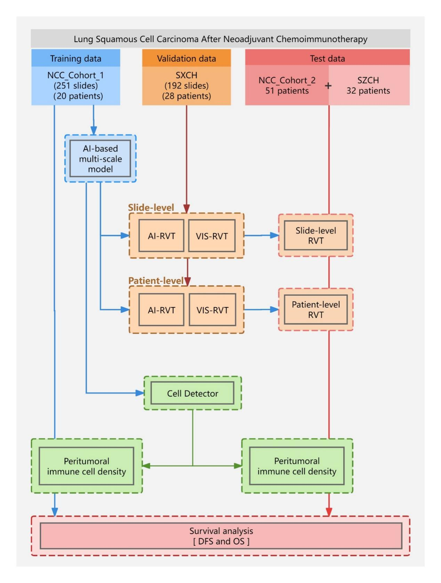
Figure 1. Study design Three independent cohorts were used to evaluate the performance and prognostic value of an AI-based multiscale algorithm for residual viable tumor (RVT) assessment in lung squamous cell carcinoma (LUSC) after neoadjuvant immunochemotherapy. The model was trained on 251 annotated whole-slide images (WSIs) from 20 patients (NCC_Cohort1), and validated using 192 WSIs from 28 patients (SXCH) to assess concordance with visual RVT estimates at both slide and patient levels. The finalized model was applied to a test set of 103 patients (20 from NCC_Cohort1, 51 from NCC_Cohort2, and 32 from SZCH) to evaluate its prognostic significance. An AI-based Cell Detector was employed to quantify stromal immune cell density around the tumor boundary. Combined RVT and stromal immune cell metrics were incorporated into survival models to assess their impact on DFS and OS.

- Data Preprocessing
In this study, we developed a workflow for computer-assisted interpretation of whole slide images (WSIs) to evaluate neoadjuvant immunochemotherapy response and prognosis. The WSI dataset contained four distinct pathological regions: tumor bed, tumor tissue, necrotic tissue, and normal regions. Each region delineated using a series of closed polygons represented by coordinates. During the reading process, we extracted the annotations using the polygon extraction module provided by Polygon(https://pypi.org/project/polygon/ ) .
First, we rescaled the images to correspond to a 20x magnification (0.5 μm/pixel) to standardize the image resolution. We then segmented the processed WSIs into non-overlapping 224×224-pixel tiles to avoid redundancy in adjacent regions. For each tile, we applied a grayscale detection algorithm to exclude blank regions. Specifically, tiles were converted to grayscale, and if the brightness range fell below 35% of the dynamic range, the tile will be discarded as containing largely irrelevant or blank areas. Following this initial screening, we used the Polygon library to calculate the proportion of each pathological region in the remaining tiles. Tiles with more than 60% of a specific pathological class were assigned to that class, while those that did not meet the criteria were discarded to ensure that the model focused on specific pathological regions.
This workflow was implemented on a computing platform consisting of 6 Intel Core i5-9400 processors, utilizing a multiprocessing strategy with a 16-process pool to enhance efficiency. Following this procedure, we obtained 975,359 tiles for subsequent model training. Additionally, we applied stain normalization techniques to account for variability in staining protocols across laboratories, which could introduce bias when processing stained images. We employed the Vahadane method for stain normalization²² , where the images were decomposed into stain concentration and color basis matrices using non-negative matrix factorization (NMF)²³ . The color basis of the reference image was aligned with that of the target image, and the image was reconstructed to ensure consistent staining effects across different WSIs.

Figure 2. A workflow for computer-assisted interpretation of whole slide images (A) Pathologist’s multi-scale workflow for WSI analysis, involving organ-, histological-, and cellular-level assessments to identify suspicious regions and evaluate disease progression. (B) Computational pathology workflow mimicking clinical reasoning: tiles are extracted and preprocessed to remove background regions, followed by training of a multi-scale classifier for comprehensive pathological analysis, and a cell counting detector is trained on tumor bed area for prognosis of cellular burden in the test dataset.
(C) Multi-scale model training pipeline: scale-specific classifiers are trained on annotated tiles at corresponding magnifications, with higher-magnification tiles derived from lower-magnification parent regions to ensure inter-scale consistency.
(D) Inference workflow: diagnostic results are generated via area-weighted fusion of outputs from all scales, integrating local (cellular) and global (architectural) features.
(E) Progressive pretraining and fine-tuning pipeline of the multi-class cell detector: the model was first pretrained on public multi-class histopathology datasets, followed by in-domain pretraining on tumor bed tiles with binary tumor-stromal labels. Final fine-tuning was performed on in-domain tiles annotated for eight-class cell detection.

3. AI model design and training
Multi-scale patch classifier. Our AI model design emulates the pathologist's "zoom-in, zoom-out" paradigm (Fig. 2a), with the overall workflow illustrated in Fig. 2b. In real-world diagnostic scenarios, it is crucial to consider the characteristics of the surrounding tissues when determining the class of a pathological region(Xiang, T., et al. DSNet: A Dual-Stream Framework for Weakly-Supervised Gigapixel Pathology Image Analysis. IEEE Transactions on Medical Imaging 41, 2180-2190 (2022). To this end, we developed a multi-scale classifier that integrates predictions at different scales. This design leverages information from the local tile and its surrounding context to improve classification accuracy, simultaneously capturing histopathological abnormalities at both the tissue and cellular levels. This study utilized 251 whole-slide images (WSIs) from 20 patients as the training set to train the classifier. The feature extraction backbone employed ResNet-101²⁵, whose deep residual architecture effectively mitigates gradient vanishing in deep networks through skip connections.
As shown in Figure 2c to ensure coordinated stability in multi-scale classifier training, we designed a receptive field expansion-based training sample generation strategy: Centered on the smallest-scale tile, progressively expanded adjacent regions were used to generate larger-scale training samples, thereby maintaining spatial continuity in multi-scale feature alignment. This construction method not only guarantees training stability for individual classifiers but also enhances the model's representational capacity for tissue heterogeneity through inter-scale topological correlations.
We extensively trained the classifier on the prepared tile dataset to suit our task. The pre-trained model weights were obtained from the repository (GitHub - yuyang-huang/keras-inception-resnet-v2). We used SGD as the optimizer with a base learning rate of 1e-4 and employed weight decay and momentum to optimize the convergence process. We use categorical cross-entropy for loss function, which is commonly applied in multi-class classification tasks. Considering the balance between computational resources and model performance, we set the training batch size to 4.
Since the tumor regions in the dataset were relatively scarce, there was a class imbalance in the tiles directly generated from the dataset. Without corrective sampling, the model would struggle to learn the features of the tumor regions. To address this, we introduced class weights to increase the sampling rate of underrepresented classes, ensuring a balanced dataset for training.
Multi-class cell detector. For comprehensive prognostic evaluation, we further developed a cell detection and classification module based on a foundation model (fig. 2e). To enable effective utilization of multiple histopathology datasets with heterogeneous annotation schemas, we adopted the large pretrained vision-language model GLIP(Li L H, Zhang P, Zhang H, et al. Grounded language-image pre-training[C]//Proceedings of the IEEE/CVF conference on computer vision and pattern recognition. 2022: 10965-10975.), which reformulates object detection as a phrase grounding task. This formulation eliminates the need for task-specific classification heads and allows large-scale public datasets with inconsistent label spaces to be jointly leveraged for learning a strong backbone. In addition, the language priors embedded in GLIP reduce reliance on extensive task-specific annotations, thereby mitigating the risk of overfitting during fine-tuning on limited data.
We trained the cell detection and classification model using a progressive pretraining - fine-tuning strategy. The model was first pretrained on publicly available multi-class cell detection datasets to adapt the natural-image pretrained representations of GLIP to histopathological imagery and to establish cell-aware visual features that serve as a foundation for subsequent in-domain refinement. We used the training sets of MoNuSAC(R. Verma, N. Kumar, A. Patil, N. C. Kurian, S. Rane, S. Graham, Q. D. Vu, M. Zwager, S. E. A. Raza, N. Rajpoot et al., “Monusac2020: A multi-organ nuclei segmentation and classification challenge,” IEEE TMI, vol. 40, no. 12, pp. 3413–3423, 2021.), CCRCC(Z. Gao, J. Shi, X. Zhang, Y. Li, H. Zhang, J. Wu, C. Wang, D. Meng, and C. Li, “Nuclei grading of clear cell renal cell carcinoma in histopathological image by composite high-resolution network,” in MIC- CAI. Springer, 2021, pp. 132–142.), and CoNSeP(S. Graham, Q. D. Vu, S. E. A. Raza, A. Azam, Y. W. Tsang, J. T. 649 Kwak, and N. Rajpoot, “Hover-net: Simultaneous segmentation and 650 classification of nuclei in multi-tissue histology images,” Medical Image 651 Analysis, vol. 58, p. 101563, 2019.) for this purpose. The model was then further pretrained using 1,318 tiles derived from WSIs of seven patients in the original training set, with cell classes labeled as tumor or stromal. This step was designed to further adapt the model to in-domain staining characteristics, while limiting the introduction of label ambiguity and subjective bias arising from fine-grained multi-class annotations with limited diagnostic certainty. Model fine-tuning was performed on carefully curated dataset with high annotation certainty to enable fine-grained multi-class cell discrimination, while building upon representations stabilized through prior pretraining. A total of 938 tiles of size 224*224 pixels were extracted through overlapping sampling from fully annotated regions in the original training set. For annotated regions smaller than 224*224 pixels, black padding was applied to maintain a consistent input size. Using the same sampling strategy, 8 tiles from the original testing set were collected for testing. Cells were categorized into eight classes: Tumor cell, Lymphocyte, Neutrophil, Eosinophil, Plasma Cell, Endothelial Cell, Fibroblast, and Histiocyte.
To maximize performance, the GLIP-L model was adopted and initialized using pretrained weights from the GitHub project (GitHub - https://github.com/microsoft/GLIP). Following the original paper, the cell category names, separated by “.”, were used as text prompts. To ensure comprehensive cell detection and reduce omission, the maximum number of detectable objects per image was set to 400. The initial learning rate was set to 1e-5, and the training batch size set to 1. Other GLIP hyper-parameters were kept at their default settings.

4. Inference and Application
During inference (Figure 2d), the WSIs were first split into tiles using the same grid method as during training, and blank regions were excluded. Next, the classifier was used to categorize the tiles. For each tile, the model generates final diagnostic outputs by integrating predictions from multi-scale classifiers. Specifically, an area-weighted fusion was performed according to the proportional area of pathological regions corresponding to each scale classifier, ultimately calculating the RVT percentage score. This fusion strategy significantly improves the biological plausibility of evaluation results by emulating pathologists' diagnostic decision-making process that synthesizes macro-scale tissue architecture with micro-scale cellular features.
The classification results were visualized as colored pixels in a thumbnail of the WSI, in which each pixel stands for a small tile.
Subsequently, for immune microenvironment analysis, we selected the largest tumor region in each WSI as the representative area and extracted five tiles surrounding its contour. For WSIs without tumor tissue, the largest stromal region was chosen, and tiles within a circular area with a radius of five tiles around the center were obtained. These tiles were processed using the trained model to obtain cell detection and classification results of the peritumoral immune cells, categorizing into the seven non-tumor classes: Lymphocyte, Neutrophil, Eosinophil, Fibroblast, Endothelial Cell, Stromal Cell, and Histiocyte. To facilitate subsequent prognostic analysis, for each detected cell, we computed the major and minor axis lengths, area, detection confidence, the vector direction and distance to the nearest tumor region, and the perimeter and area of that region.

5. Performance evaluation of AI model
AI model evaluation. To assess the multi-scale architecture, we compared the multi-scale patch classifier against a single-scale baseline. Performance was evaluated using F1-score, precision, and recall as evaluation metrics²⁷.
The multiclass cell detector was benchmarked against a Mask R-CNN²⁴ trained under the same training pipeline and a GLIP model without additional pretraining. Mask R-CNN used a ResNet-50²⁵ backbone, hyperparameters were kept at their default settings. Performance was evaluated using AP50(Lin T Y, Maire M, Belongie S, et al. Microsoft coco: Common objects in context[C]//European conference on computer vision. Cham: Springer International Publishing, 2014: 740-755.) across seven peritumoral immune cell categories.
Clinical statistical analysis. The RVT value for each case was derived by averaging the RVT percentages across all available slides. To assess the reliability of the AI-derived RVT measurements, ICCs were calculated to evaluate concordance among different assessment methods. Progression-free survival (PFS) and overall survival (OS) were used as clinical endpoints. Univariable survival associations were examined using Kaplan-Meier analysis with log-rank testing, while multivariable effects were evaluated using Cox proportional hazards models.
All statistical analyses were conducted using R software (version 3.6.0, accessible at https://www.r-project.org/), ensuring methodological rigor and reproducibility in the analysis process.
.

